
Yunnan University Software College Machine Learning Report
School of Software, Yunnan University
Personal Grades
(Students fill in (except the last column))
Student number | Name | Major | Score
20233120042 | Rabby Md Golam | Artificial Intelligence

Semester: Fall 2025
Course Name: Professional Training (Intermediate)
Teacher: Ahmed Zahir
Project Name: NLP Intelligence Hub: A Multi- Models Transformer-Based Intelligence
Applicatiotn
Team Leader: Rabby Md Golam
Report completion Date: 11 December, 2025
Abstract
This project presents the design and implementation of the NLP Intelligence Hub, a fully containerized, multi-model Natural Language Processing (NLP) application that integrates deep learning models, vector search, and a modern web interface. The system supports sentiment analysis, semantic search, text summarization, and image captioning, using locally stored transformer-based models without relying on external APIs. The system leverages transformer-based architectures from Hugging Face and Sentence-BERT to perform fast and high-quality text processing tasks.
A key component of this system is the integration of ChromaDB, a vector database used for embedding storage, semantic retrieval, and automated logging of user interactions. The backend is implemented using FastAPI, while the frontend is built with Streamlit, providing an intuitive interface for real-time NLP tasks. The entire application runs inside a multi-container Docker Compose environment, ensuring reproducibility, portability, and production-ready deployment.
This report demonstrates how deep learning, embeddings, vector similarity search, and container orchestration can be integrated into a complete, real-world NLP system aligned with course requirements. Experimental outputs, workflow diagrams, evaluation of results, and discussion of challenges are included.
Code will be available GitHub Repositories https://github.com/Rabby0501/NLP-Intelligence-Hub
Keyword: Natural Language Processing, Deep Learning, Transformer Models, Embeddings, Vector Databases, ChromaDB, Semantic Search, Streamlit, FastAPI, Docker, Containerization, LLM, Summarization, Image Captioning, Sentiment Analysis

1. Introduction

1.1 Motivation for the NLP Tasks
Modern applications require intelligent processing of text and images tasks such as sentiment classification, question answering, summarization, and semantic retrieval. These capabilities are foundational for real-world systems including customer feedback analytics, search engines, document assistants, and multimodal media platforms.
The motivation for this project was to build a complete, end-to-end NLP system that reflects current industry practices combining:
- Analyzing sentiment from user text ()
- Performing semantic search using transformer embeddings
- Generating summaries of long content
- Producing captions from images
- Storing and retrieving embeddings via a vector database
The goal is to explore the power of transformer-based architectures and practical deployment of NLP models in real-world environments.

1.2 ML and Deep Learning Background
Traditional machine learning models such as Naïve Bayes or SVM struggle with contextual understanding. Transformer models, especially those using self-attention mechanisms, revolutionized NLP by:
- Capturing long-range dependencies
- Learning deep semantic representations
- Achieving state-of-the-art performance on multiple tasks
This project uses several transformer families:
Model | Purpose | Key Architecture / Note
DistilBERT sentiment model | Sentiment classification | Distilled BERT, efficient for real-time sentiment analysis
sentence-transformers (MiniLM) embedder | Semantic embeddings | Produces 384-dimensional embeddings for semantic search
distilbart-cnn-12-6 summarizer | Abstractive summarization | Distilled BART with 12 encoder & 6 decoder layers
BLIP image captioning | Vision-Language captioning | Unified vision-language pre-training for caption generation

Table 1: Transformer Models and Their Applications

Vector databases such as ChromaDB store embeddings and allow efficient k-nearest neighbor (kNN) retrieval, enabling semantic search and contextual operations.

1.3 Why Transformers, LLMs, and Vector Search Matter
- Transformers enable:
- contextual embeddings
- scalable inference
- multi-task learning
2. LLMs (e.g., T5, GPT, BERT) are capable of:
- text generation
- summarization
- answering questions
- reasoning over documents
3. Vector search systems like ChromaDB allow:
- similarity-based retrieval
- efficient semantic search
- indexing large corpora

2. Literature Review

2.1 Semantic Search Systems
Semantic search replaces keyword matching with embedding-based retrieval. Research such as SBERT (Reimers & Gurevych, 2019) demonstrates that sentence embeddings significantly improve search quality.
- Word2Vec / GloVe
- Universal Sentence Encoder
- Sentence-BERT, which produces high-quality sentence embeddings
SBERT and MiniLM embeddings are widely used for commercial semantic search engines.

2.2 Transformer Architectures
Key models used in this project:
- DistilBERT: lightweight encoder for sentiment classification
- Sentence-BERT MiniLM: efficient semantic embedding model
- distilbart-cnn-12-6: model for summarization and generation
- BLIP: transformer-based multimodal caption generator
Transformers dominate NLP due to superior parallelism and contextual understanding.

2.3 Vector Databases
Vector DBs support semantic similarity with millisecond retrieval. Popular systems:
- FAISS (Facebook)
- Milvus
- Weaviate
- Pinecone
- ChromaDB (used in this project)
ChromaDB offers persistent storage, metadata support, and efficient indexing. It’s also Lightweight design, Embedding storage, Fast query operations, Easy of use with Python

2.4 LLM Frameworks
- LangChain: Enables RAG, chaining, prompting, and memory management.
- Hugging Face Transformers: Provides pre-trained models and pipelines for NLP tasks.
This project uses Hugging Face for model inference and Chroma for vector retrieval.
simplify LLM use in production. Our project integrates these technologies through custom pipelines and local models for offline inference.

3. System Design

3.1 ML Pipeline Diagram
This pipeline shows the operational flow of the application. Text and images go through preprocessing, the appropriate deep learning model executes (sentiment classifier, summarizer, SBERT embedder, BLIP caption model), and in the case of semantic search, dense embeddings are stored and retrieved from ChromaDB. All results are delivered to the backend API and rendered in Streamlit.
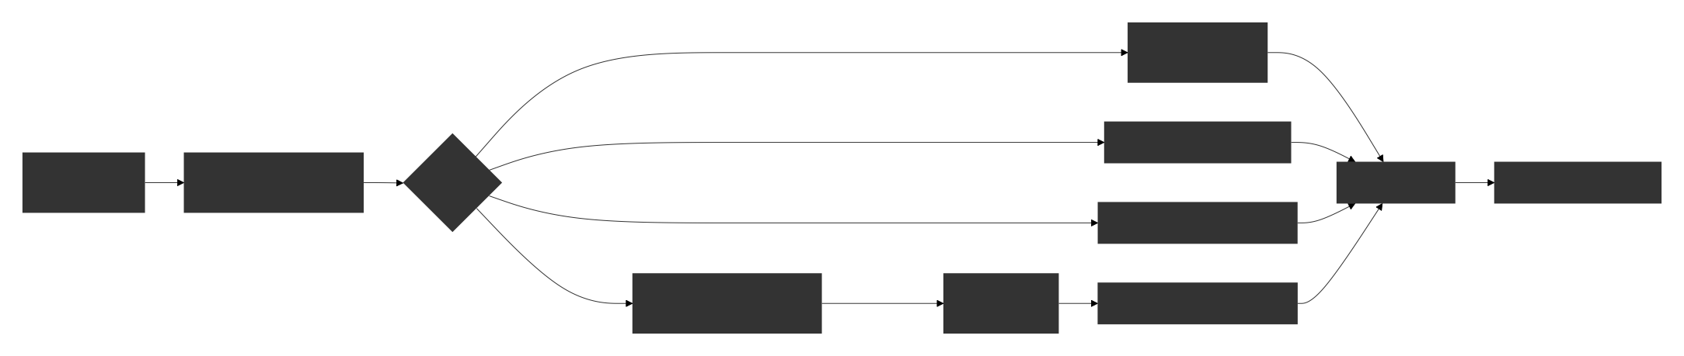
Figure 1: End-to-end ML pipeline demonstrating how user inputs flow through preprocessing, deep learning models, embedding generation, vector database retrieval, and frontend visualization.

3.2 Data Preprocessing Workflow
This diagram illustrates a sequential text preprocessing pipeline designed to transform raw user input into model-ready format for NLP tasks. The workflow consists of four main stages: 1) Text Cleaning converts text to lowercase and removes URLs and HTML tags; 2) Tokenization splits text into individual words using regular expressions; 3) Normalization cleans up whitespace and formatting inconsistencies; 4) Preprocessing for Model prepares the cleaned, tokenized text for Transformer-based models like Sentence-BERT. This systematic approach ensures textual data is properly formatted, standardized, and optimized for downstream natural language processing tasks including sentiment analysis, semantic search, and text summarization.

Figure 2: Data preprocessing workflow including cleaning, tokenization, normalization, and preparation for model inference.

3.3 Embedding Generation Diagram
We use a local SBERT MiniLM model to convert text into dense numerical vectors. These embeddings are inserted into ChromaDB and later used for semantic search queries.
Figure 3: Embedding generation flow showing how cleaned text is converted into dense vectors and stored in ChromaDB for similarity search.

3.4 Vector Database Architecture
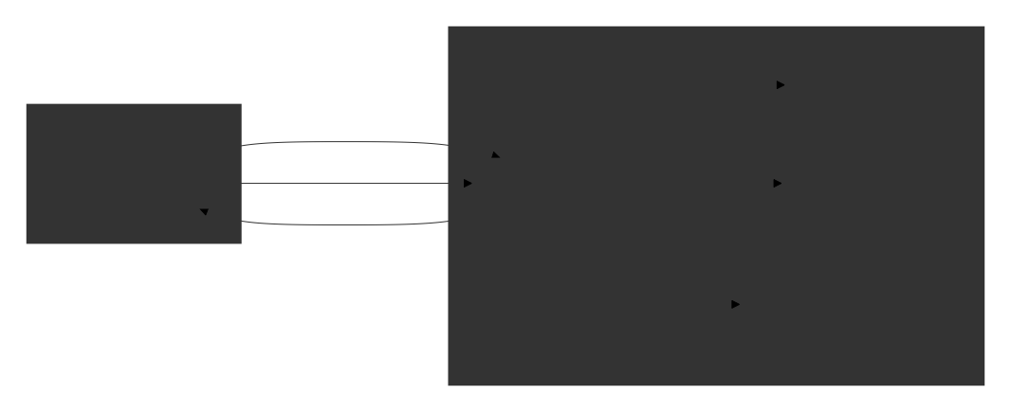
The vector database stores embeddings and structured metadata. When a query embedding arrives, ChromaDB performs an approximate nearest neighbor (ANN) search to retrieve semantically relevant items. The metadata enrichment allows for filtered searches and better result organization, while the vector-based storage enables efficient similarity computations crucial for NLP applications like document retrieval, recommendation systems, and knowledge base search.
Figure 4: Vector database architecture illustrating how embeddings, metadata, and documents are stored and retrieved using ChromaDB.

3.5 Docker Container Architecture
- Frontend Container: Hosts a Streamlit web interface on port 8501 for user interaction
- Backend Container: Contains FastAPI server on port 8000 with integrated local ML models (Sentiment analysis, Sentence-BERT embeddings, distilbart-cnn-12-6 for summarization, and BLIP for image captioning)
- VectorDB Container: Runs ChromaDB vector database on port 8001 for semantic search
The architecture shows bidirectional communication: the frontend makes REST API calls to the backend, which processes requests using local models and interacts with the vector database for embedding storage/retrieval. Processed results are returned as JSON responses to the frontend for display. This design supports multiple NLP tasks through a unified API while maintaining separation of concerns between UI, business logic, and data storage layers.
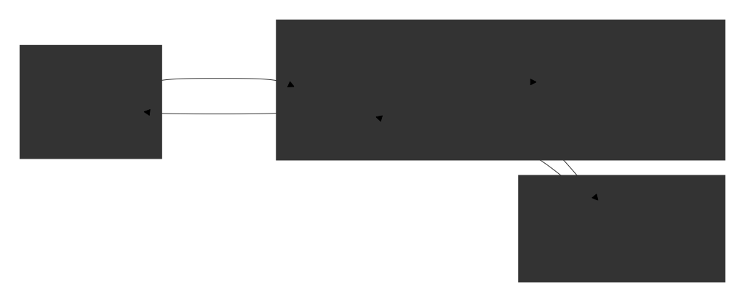
Figure 5: Docker-based deployment architecture showing the three isolated services: frontend UI, backend API with deep learning models, and ChromaDB vector database.
3.6 Full System Architecture with Multi-Modal NLP Services
This diagram presents the complete architecture of a multi-modal NLP intelligence system built as a containerized microservices application. The system supports four primary NLP capabilities (sentiment analysis, semantic search, text summarization, and image captioning) through a three-tier architecture:
Architecture Overview
- User Interface Layer: A Streamlit web application running in a Docker container on port 8501, providing browser-based access to end users
- Processing Layer: A FastAPI backend service (port 8000) hosting four specialized NLP models:
  - Sentiment Model for emotion/opinion classification
  - Sentence-BERT Embedder for semantic text representations
  - Summarizer (distilbart-cnn-12-6) for text condensation
  - BLIP Model for vision-language tasks (image captioning)
- Storage Layer: A ChromaDB vector database (port 8001) storing the nlp_corpus collection with documents, embeddings, and metadata

Data Flow Patterns:
- Request Flow: Browser → Streamlit UI → FastAPI → (Models/ChromaDB)
- Response Flow: (Models/ChromaDB) → FastAPI → Streamlit UI → Browser
- Vector Operations: FastAPI generates embeddings via Sentence-BERT, stores them in ChromaDB, and queries them for semantic search
- Multi-Modal Processing: The system handles both text (sentiment, summarization, embeddings) and images (BLIP captioning)

Technical Implementation:
- Container Orchestration: Each component runs in isolated Docker containers with defined port mappings
- API Communication: REST/JSON interfaces between services
- Model Specialization: Each NLP task uses an optimized model (e.g., distilbart-cnn-12-6 for efficient summarization)
- Vector Search: ChromaDB enables similarity-based retrieval using precomputed embeddings

System Capabilities:
This architecture enables users to submit text or images and receive multiple intelligent responses including sentiment scores, document summaries, image captions, and semantically relevant search results from a knowledge base all through a unified web interface.

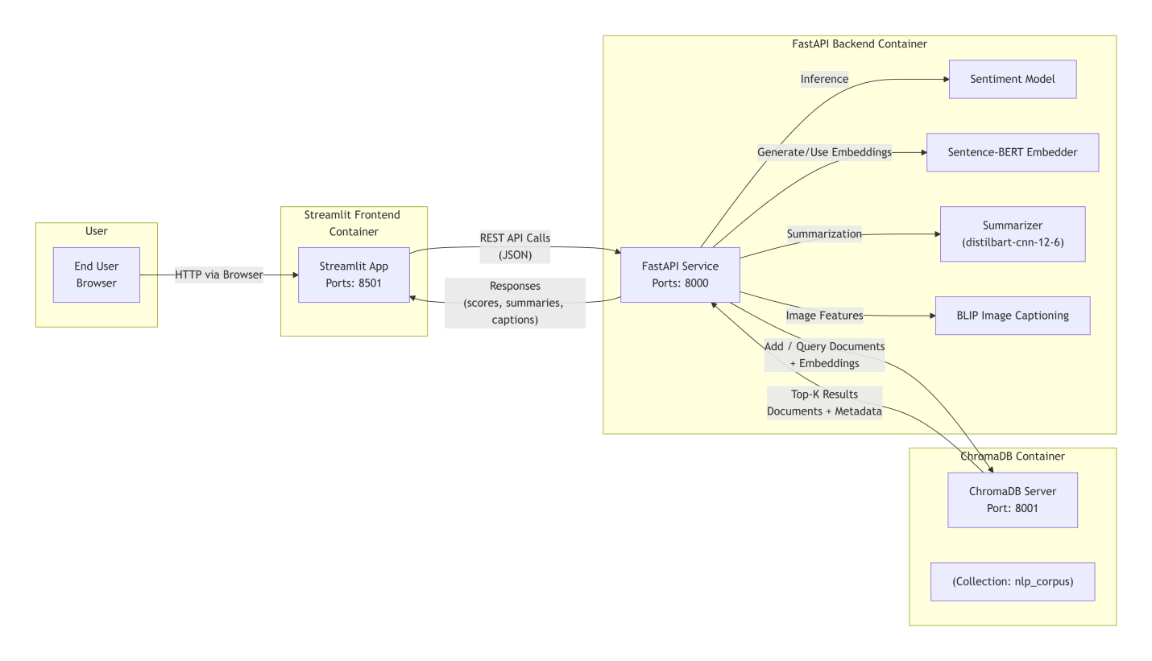
Figure 6: Unified system architecture summarizing the flow from frontend input to backend processing, deep learning inference, vector database retrieval, logging, and final user interaction.
3.7 Summary of System Design
In summary, the NLP Intelligence Hub implements a modular and containerized architecture combining a Streamlit UI, a FastAPI backend hosting multiple transformer and multimodal models, and a ChromaDB vector store for semantic retrieval and logging. The system integrates a shared preprocessing pipeline, embedding generation, and structured metadata, fulfilling the course requirements for deep learning usage, vector database integration, application interface, and Docker-based multi-service deployment.

